# TASK DESCRIPTION #1

OPEN GOOGLE COLAB AND USE GOOGLE GEMINI TO GENERATE PYTHON CODE THAT PERFORMS SORTING OF A LIST USING BOTH THE BUBBLE SORT ALGORITHM AND PYTHON’S BUILT-IN SORT() FUNCTION. COMPARE THE TWO IMPLEMENTATIONS.

EXPECTED OUTPUT:

TWO SORTING IMPLEMENTATIONS

# TASK DESCRIPTION #2

A PYTHON FUNCTION THAT TAKES A STRING AND RETURNS: THE NUMBER OF VOWELS, CONSONANTS, AND DIGITS IN THE STRING

EXPECTED OUTPUT:

COMPLETE FUNCTIONS THAT ITERATE THROUGH CHARACTERS OF THE STRING AND COUNT VOWELS, CONSONANTS, AND DIGITS

Output:

# TASK DESCRIPTION #3

Create a text file.

Write sample text

Read and display the content

EXPECTED OUTPUT:

Functional code that creates a .txt file, writes content to it, and reads it back

Output:

# TASK DESCRIPTION #4

Generate a Python program that implements a simple calculator using functions (add, sub,mul, div ). Then ask Gemini to explain how the code works.

Output:

Complete calculator code with user input and operation selection

Line-by-line explanation, markdown-style explanation provided by Gemini

Screenshot of both the code and code and explanation in Colab

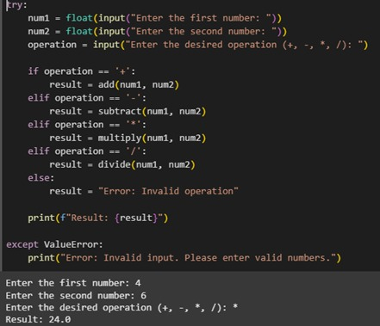

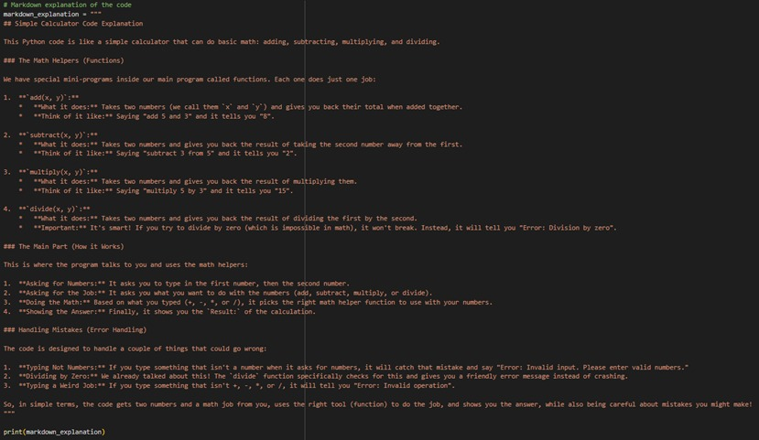

# TASK DESCRIPTION #5

Use gemini to create a python program that checks if a given year is a leap year or not .try different prompt styles and see how gemini modifies its code suggestions.

OUTPUT:

A functional program to check a leap year with sample input/output

• At least two versions of the code from different prompts

• A short comparision of which version is better and why



